**Changes to be implemented for APSIM sugarcane**

It is expected that the software engineering is to be conducted in two stages:

1. Changes requested below are made available as a prototype (beta) version for testing by sugarcane modellers
2. Changes are made available for general use via the sugar.ini file
3. **Transpiration efficiency**

*Step 1. Intrinsic water use efficiency (k) = transpiration efficiency (TE)= ‘transp_eff_cf’*

This is defined for each growth stage as ‘transp_eff_cf’ in APSIM at present. We want *k* to depend on water stress (*S*) defined as the ratio of water supply to water demand *(D)* rather than on the growth stage (as is the case presently in APSIM):

*S* = root water supply/ sw_demand = W/D (1)

Daily transpirational demand (D) is derived thus:

*D = R(1-exp(-E.LAI)) * RUE * VPD / k* (2)

Where:

*R* = Daily radiation (MJ/m2)

*E* = extinction_coef

*k* = y_transp_eff_cf (g kPa/Kg)

*RUE* = radiation use efficiency (g/MJ)

*LAI* = leaf area index

*VPD* = Mean daily vapour pressure deficit

I am not sure what the APSIM name is for root water supply (sw_supply I think) but it is assigned to ‘RWU’ in WATBAL in CERES-Maize.

*W = RWU = Σ(KLn * ESWn) for n = 1 to nlayr* (3)

The user must be able to set the response to water stress as in this example where k = 8.7 g KPa/kg when demand is fully met by root water supply and *k* increases proportionally to 10.0 g KPa/kg when water supply is zero.

x_stress_photo = 0 1

y_transp_eff_cf = 0.0100 0.0087

Please use the typical APSIM extrapolation system so we can have a more complex relation to *S* if we want. Data below obtained by Jaya and Phil suggest a response to stress something like:

x_stress_photo = 0 0.2 0.8 1

y_transp_eff_cf = 0.004 0.0150 0.0087 0.0087 (Kg KPa/Kg)

|  |  |
| --- | --- |
|  |  |

Computational procedure:

1. Derive *S*temp (temporary variable) as in equation 1,2 & 3 using the non-stressed value of *k* (*k0* = 0.0087 in the example)
2. Derive actual *k* (*ka*) for the day (or hour) from x and y parameters above, using Stemp
3. Calculate *D, S* and biomass gain for the day as normal using *ka*

*Step 2: Develop hourly temperature, radiation and VPD values from daily data*

This may have already been done by Scott Chapman and Graeme Hammer for sorghum. Exactly how this is done is left up to the SEG team but some references are given below that may help.

Hourly temperature, radiation and VPD from three reliable automatic weather stations in three regions -Bundaberg, Burdekin and Ord - need to be simulated from daily maximum and minimum temperature and daily radiation. The equations need to account for >90% of the variation in hourly values for at least two years of data.

‘Development of Hourly Meteorological Values From Daily Data and Significance to Hydrological Modeling at H. J. Andrews Experimental Forest. Scott R. Waichler and Mark S. Wigmosta (2003) Journal of Hydrometeorology.

Stockle, Williams, Rosenberg and Jones (1990) may help (Agricultural Systems 38 (1992) 225-238) and Doorenbos & Pruitt, (1977)

*Step 3: Derive maximum hourly transpiration rate from hourly radiation, and VPD estimates.*

1. When root water supply is limiting

Potential hourly transpiration (TOi) for the ith hour

*TOi = Ri(1-exp(-E.LAI)) * RUE * VPDi / ka*

Where:

*Ri* = hourly radiation (MJ/m2) as derived in step 2

*VPDi* = hourly vapour pressure deficit as derived in step 2

*ka =* as derived in step 1

Actual hourly transpiration = *TAi = min(TOi ,  W*i*)*

Where *Wi* is root water supply for the *i*th hour which is the maximum value obtainable when hourly *Wi* adds up to the daily value. *W* is a daily not an hourly construct and we assume that when supply (W) cannot meet demand on a daily basis, this limits transpiration when the demand is highest, in the middle of the day. Thus in the example below, if root water supply (W) is 5 mm for the day and the sw_demand *(D)* is 6.45 mm, actual hourly transpiration will be limited from 10 to 15 h by a maximum hourly root water supply which is 0.558 mm in this case. Please talk to the sorghum modellers to see how to code this bit up. I can’t think of a calculus solution here, it may have to be done iteratively.

|  |  |  |
| --- | --- | --- |
| Hour | T0i | TAi |
| 6 | 0.05 | 0.050 |
| 7 | 0.1 | 0.100 |
| 8 | 0.3 | 0.300 |
| 9 | 0.5 | 0.500 |
| 10 | 0.7 | 0.558 |
| 11 | 0.8 | 0.558 |
| 12 | 0.9 | 0.558 |
| 13 | 0.9 | 0.558 |
| 14 | 0.8 | 0.558 |
| 15 | 0.7 | 0.558 |
| 16 | 0.5 | 0.500 |
| 17 | 0.2 | 0.200 |
| Total | 6.45 | 5.000 |

1. Where stomatal conductance is limiting

For this, the user can set maximum transpiration rate and in so doing allow the crop to avoid the effects of water stress on leaf expansion. We could, for example, set maximum transpiration to 0.558 in the above example. This will have the effect of just keeping the crop from water stress as it affects photosynthesis. Thus *S = W/D = 1*. However leaf and stalk growth will be affected but not as badly as would have been the case where transpiration rate was unlimited. However because we have deliberately reduced transpiration we will also have reduced photosynthesis (step 4).

Stomata may close earlier than required to limit transpiration to match soil water supply. This could be mediated by root signals responding to low soil water potentials or could be a direct effect of VPD on the action of guard cells which control stomatal aperture. VPD and soil water supply are both captured by S and we want maximum transpiration rate (transmax) therefore to be responsive to S as in:

Reviewers of the project in January 2014 suggested that to vary the limit of hourly potential transpiration with stress is confounding the stress effect with the stress effect applied in point 1) above. They suggested that a root signal type limit to transpiration (conductance) not be linked to stress. I agreed at the time but I think they are wrong now. If y_transmax below can only be set once it will be pretty useless. It will be like imposing a general limit on leaf area regardless of the stress environment. It has to be modified by stress as originally planned. We asked (below) for that stress to be the demand/supply ratio and we’ll have to leave that to be for now. A demand only or supply only stress could be used in future unless we want to build that choice in now.

x_stress_photo = 0.3 1

y_transmax = 0.1 0.558 (mm) ! just an example

In the above example, hourly transpiration will be limited to 0.558 mm when there is no water stress (extreme example) and will be limited to 0.1 mm when S = 0.3.

*Step 4. Derive hourly biomass accumulation (B) in the same way that daily biomass gain is determined in APSIM.*

Interestingly a reduction in hourly transpiration through the setting Transmax may not have the same advantages as if transpiration is limited through root water supply because *k* may be set to increase when *S* falls below 1 (step 1).

Shaun pointed out that there will be discrepancies in the daily totals for potential transpiration depending on hourly (step 3) or daily (default) ways of calculation. The discrepancies are small (see attached worksheet) and we asked Shaun to proceed as planned. There will also be differences in biomass accumulation and we will accept these as well and use the hourly derived daily total values. This applies to stress limited transpiration and biomass accumulation as well.

1. **Root water supply to be derived from root length density**

Phil Jackson is concerned that traits for vigour (leaf area and RUE) do not link with root water uptake (RWU) capability in the APSIM sugarcane model even though this link appears to be described in the Keating et al (1999) paper. After the January review it was decided to investigate the possibility of getting this link to work in APSIM as an alternative to the current kl based approach. The user should be able to select one or the other method. This step should take precedence over following steps which have been renumbered below.

Shaun and Geoff discussed this point at length and Shaun is now aware of what variable in the code (representing root length per layer) to use in the derivation of potential root water supply. Based on the excerpts below from Monteith and Greenwood (1986) and Robertson et al (1993) and separating *k* and *l*, root water uptake for layer n is:

RWU(n) = RLV(n) * 100 * KL(n) * ESW(n) mm/d

RLV is reported in mm/mm3 in APSIM so the 100 multiplier converts RLV to cm/cm3

Change in soil water content (theta) in eqn 2 of Robertson is in cm3/cm3/d and theta is in cm3/cm3 .

ESW is in mm per layer rather than cm3/cm3 so RWU is also in mm/layer/d which is what we want to determine potential or actual water uptake per day.

Currently RWU derived as:

RWU(n) = KL(n) * ESW(n) mm/d

So kl will have to be decreased about kl*100/rlv to achieve the same result and we would not expect kl to decline necessarily with depth because it is determined entirely by the physical properties of the soil. In the example below I set kl = 0.05 for each layer. Total potential RWU determined using RLV (rwu_tot2) was lower initially than total RWU determined kl (rwu_tot1) as given in the simulation because roots were still developing at depth. Root development will be responsive to biomass gain which is what we want.

|  |  |
| --- | --- |
|  |  |

In the example below I reduced the stalk population from 10 to 2 per m2. Biomass accumulation was reduced considerably as expected. RWU was initially greater for the low population situation because less water was used by the crop but later during a rainy period, RWU was lower for the low population ‘variety’ because of poor root development.

|  |  |
| --- | --- |
|  |  |

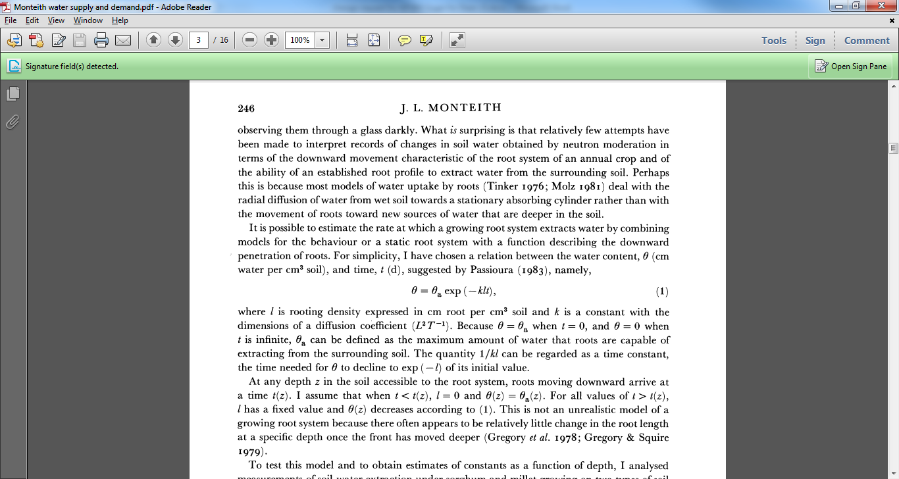

Monteith, J. L., and D. J. Greenwood. "How Do Crops Manipulate Water Supply and Demand?[and Discussion]." *Philosophical Transactions of the Royal Society of London. Series A, Mathematical and Physical Sciences* 316.1537 (1986): 245-259.

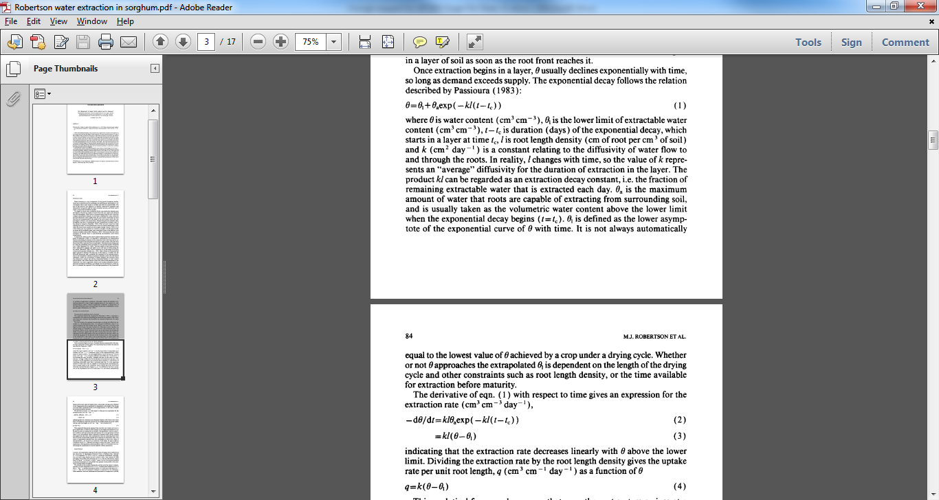

**Robertson, M. J., Fukai, S., Ludlow, M. M., & Hammer, G. L. (1993). Water extraction by grain sorghum in a sub-humid environment. I. Analysis of the water extraction pattern. Field Crops Research, 33(1), 81-97.**

1. **TE and CO2**

CO2 has a dominant effect on k (transp_eff_cf) or TE so please allow for the kind of response below and also allow CO2 levels to be set in the manager file or to be read in from the climate (met) file.

y_transp_eff_cf is a multiplier for modifying *k* as in step 1

transp_eff_cf_fact = 1.0 1.25

x_CO2 = 375 720 ppm

1. **RUE and CO2**

Despite the overriding effect of CO2 on TE, RUE may increase in CO2 enriched air because of increased Ci so please allow for this as in:

RUE_CO2_fact = 1.0 1.01

x_CO2 = 375 720 ppm

1. **Radiation use efficiency and respiration**

Sugar respiration may be responsible at least partly for the growth slow-down phenomenon (GSP) particularly for late plantings or late ratoon crops when a large quantities of labile sucrose are present and temperature are high. Please provide a sucrose respiration fraction (y_suc_resp_fr) that depends on mean daily temperature in a user defined manner something like this.

x_tmean = 10 15 20 25 30 35

y_suc_resp_fr = 0 0 0.0005 0 0.001 0.002 0.005

Sugar_respiration = sucrosewt * y_suc_resp_fr

Biomass_gain= Biomass_gain - Sugar_respiration

1. **Radiation use efficiency and leaf no.**

We know that photosynthesis declines with age in whole plants of sugarcane. This seems to be a developmental phenomenon but could be associated with the N balance but attempts to keep SLN high with fertigation have mostly failed. So please allow for RUE to vary with leaf something like:

RUE_fact = 1 1 0.8

leaf_rue_no = 1 30 50

This is more useful than the stage based selection of RUE we have currently in APSIM-Sugarcane.

1. **Delayed recovery in stress coefficients (swdef) DEVELOPMENT IN PROGRESS**

In APSIM-sugarcane, water stress  **(***S* = root water supply/ sw_demand = W/D) is relieved as soon as there is enough rain or irrigation to at least supply transpiration demand for the next day. In reality it may take a few days for this recovery to occur fully. Can we give the user a chance to determine the number of days for full recovery? This could be done by calculating a moving average for S. The user would enter 1 for determining S as is. An entry of 3 would allow 3 days for full recovery, provided W>D. Of course this value would also delay the onset of stress.